[ FODDIE ]

**Project Progress Report**



**Department of Electrical and Computer Engineering North South University CSE 299: Junior Project Design**

**Group Member:**

**1. Md. Ahasun Kamal (1530187042) 2. Sifat Anwar(1812887642)**

**TABLE OF CONTENTS**

1. **PROGRESS & ACHIEVEMENTS**
2. **OBSTACLES**
3. **MILESTONES & REPORTING**

**1.PROGRESS & ACHIEVEMENTS**

Both team members worked together to:As part of Stage-2 of our timeline submitted in

Progress report-3.In this week one group member work on use case daigram in this project. that we will use to create our project so that the both members will be easier to impelemention understand.

1. Sifat anwar charge to work on use case daigram.The initial draft of use case daigram is uploaded on our GitHub Wiki.

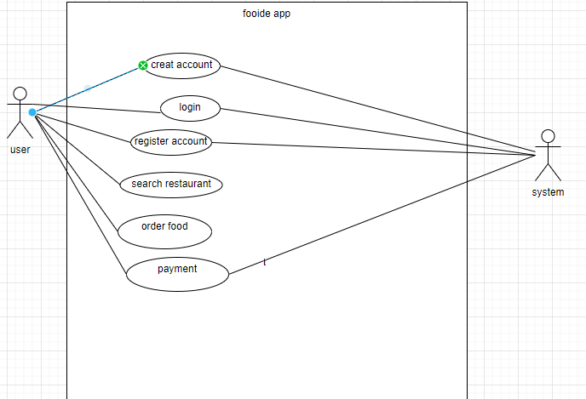

# OBSTACLES

In this section we faced some problems in databased scheme.We fixed the problem it further.otherwise there no problem yet.

# MILESTONES & REPORTING

According to our original Project Proposal, we have completed Stage-3 of our timeline. The team will start working on Stage-4immediately.

|  |  |  |
| --- | --- | --- |
| **Milestone** | **Tasks** | **Date** |
| Week-1 | Project idea and proposal | 03-07-2021 |
| Week-2 | New language learning and codinng standerd | 11-07-2021 |
| Week-3 | Design work plan | 18-07-2021 |
| Week-4 | Create database | 25-07-2021 |
| Week-5 | User case daigram | 07-08-2021 |
| Week-6 | Add factionality | 15-08-2021 |
| Week-7 | Create GUI | 20-08-2021 |
| Week-8 | Database connection | 27-08-2021 |
| Week-9 | Progress Report Due | 02-09-2021 |
| Week-10 | Final presention | 05-09-2021 |
| Week-11 | Final report(thesis) | 12-09-2021 |